**CSCI/CMPE 4301 DIP Guide**

**Exam-05 (Final Exam)**

**Due by**

**Name: 04/27/22**

**There will be no late submission (with or without penalties)**

1. (25) Understanding Support Vector Machines

**https://www.youtube.com/watch?v=ik7E7r2a1h8**

This question comes exactly from the above video with my own set of points.

Given the following set of points (with their yi labels) in 2-D

(1,0) and (3,0) belong to yi= +1 (i.e., positive examples)

(2,2) and (2,3) belong to yi= - 1 (i.e., negative examples)

1. Draw the data in 2-D with the labels.
2. Find intuitively the line equation with the largest margin and write its equation as y = m*x* + b
3. Rewrite the equation in the famous form **w**.**x** + b = 0 where **w** and **x** are vectors and **.** is the dot product.
4. Scale the equation such that margin width = 2/||w||
5. Find the supportiveness (a values) of all the 4 points.
6. (25) Confusion Matrix

A classifier is used on 30 male patients to screen for cancer. Having cancer is considered TP and not having cancer is considered TN. Of the 30 males 19 are healthy and 11 have cancer.

The classification gives the following results: 8 cancer patients are classified as having cancer (TP). 2 healthy patients are classified as having cancer (FP). 17 healthy patients are classified as healthy (TN). 17 healthy patients are classified as healthy (TN). 3 cancer patients are classified as healthy (FN)

1. Draw the 2x2 table.
2. Calculate the overall accuracy after giving the formula.
3. Calculate the Precision and recall values.
4. Calculate the F value.
5. Which measure is more important, and why?
6. (25) Data Augmentation

Given one image of utb.jpg, generate (using Keras or any package of your choice) 30 or more variants of the image through the following DIP operations:

* Scaling
* Flipping
* Rotations
* Translation (shifting)

The program/notebook must allow the use to input the image. Check the site at for a nice tutorial.

<https://machinelearningmastery.com/how-to-configure-image-data-augmentation-when-training-deep-learning-neural-networks/>

1. (25) Feedforward Fully Connected NN: for the A small,

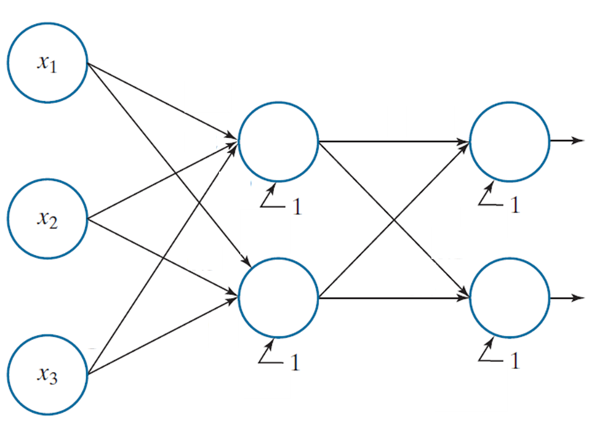fully connected, feedforward net with labeled weights, biases, and outputs. The activation function is sigmoid. Show all the details/

$$\overset{⃑}{x}=a(1)=\left[\begin{matrix}2 \\ 1 \\ 0\end{matrix}\right] and w(2)=\left[\begin{matrix}.1 & .2 & .3 \\ .4 & .5 & .6\end{matrix}\right] and b(2)=\left[\begin{matrix}.2 \\ .1\end{matrix}\right]$$

$$and w(3)=\left[\begin{matrix}.1 & .2 \\ .2 & .1\end{matrix}\right] and b(3)=\left[\begin{matrix}.5 \\ .5\end{matrix}\right]$$

$$a(2)=\left[\begin{matrix}? \\ ?\end{matrix}\right] and a(3)=\left[\begin{matrix}? \\ ?\end{matrix}\right]$$